**SHRI GOVINDRAM SEKSARIA INSTITUTEOF TECHNOLOGY AND SCIENCE, INDORE**



**DEPARTMENT OF ELECTRONICS &TEELECOMMUNICATION**

**ENGINEERING**

Electronics Workshop -I

(EC 25992)

A PROJECT ON

**“Water Level alarm”**

**(Batch:2017-21)**

**SUBMITTED TO: SUBMITTED BY:**

Mr. Ashwin Srivastava Sir DurgeshYadav(0801EC171031)

Mr. Gopikrishnan Sir Naman Jain (0801EC171052)

PankajKumar(0801EC171055)

**CONTENT:**

1. CERTIFICATE

2. ACKNOWLEDGEMENT

3. INTRODUCTION

4. CIRCUIT DIAGRAM

6. WORKING

7. APPLICATION

8. BIBLOGRAPHY

9. RESULT & CONCLUSION

**CERTIFICATE**

This is to be certified that the project entitled “AUTOMATIC CAR WITH OBJECT DETECTION” is an original work carried out by *Durgesh Yadav, Naman Jain, Pankaj Kumar* in partial fulfillment for the award of degree of Bachelor of Engineering of Shri Govindram Seksaria Institute of Technology & Science, Indore, during the year 2018-19. The report has been approved as it satisfies the academic requirements and the students have worked under my guidance as directed.

Signature-

Mr. Ashwin Srivastava Sir

Mr. Gopikrishnan Sir

**ACKNOWLEDGEMENT**

I am thankful to the director of this college, Dr. R K Saxena sir for giving me the opportunity to make this project. The kind of learning I have gained while working on this project has proved to be invaluable.

I am extremely grateful to Mr. Ashwin Srivastava Sir and Mr. Gopikrishnan Sir my supervisor and mentor for always showing me the way and guiding me through the process of my internship.

I would like to thank my friends for giving me all the support I required and making all necessary arrangements for me to complete this research as well as the freedom to take my work in the direction I desired.

I am thankful for all of my respondents without whom this study would not have been possible.

I Would also like to thank to my parents and team members for supporting me.

**INTRODUCTION**

**Water Level Indicator. Nowadays everybody has overhead tank at their homes. But everyone who has a water tank above knows the kind of problems that they face. Firstly there is no system to track the water in the tank. Then there come a secondary problem that is when their water pump is started they have no idea when it gets filled up and sometimes there are situation where the pump keeps on pumping water to the tank and the water starts spilling out from the tank. There is wastage of energy as well as wastage of water.**

**LIST OF COMPONENETS**

**(i) The Sensor Part**  
It is generally a fixed support inside the tank having some nuts and bolt with wires coming out.  
**(ii) The Circuit Part**  
It comprises the brain of the module, where in all the various inputs from the sensors are fed. It is the unit from where you will get all the information of how much of water is in the tank.  
**(iii) The Power Supply**  
It is the part where in you will be converting the A/C voltage to a regulated voltage of 5V to the Circuit.  
***(IV) The Buzzer Part***  
It is responsible for bringing up the sound when the water level fills up in the tank. It will also be having a speaker or a buzzer to alert.

**CIRCUIT DIAGRAM**

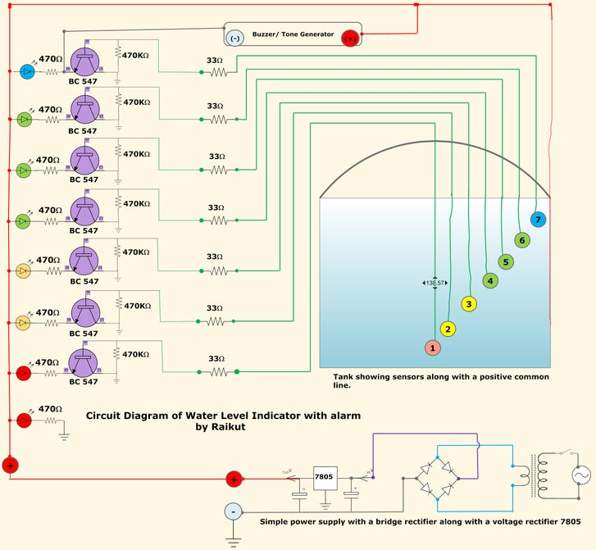

**WORKING**

The heart of the circuit is the transistors BC 547. There are total7 transistors in the circuit and each one will be sensing the level of water present in the overhead water tank. There is one extra power LED without a transistor and that is because this Red LED will be telling us two things. Firstly when you power the unit it will be monitoring the power present in the unit and secondly it is also the indicator telling you that there is no water at all present in the tank. As because the water level is below the No. 1 (as shown in the circuit) sensor, no LED's will be lighting up, but only for the one Red LED. Therefore when you switch on your unit if you see only one Red LED lighting up then you know that the is no water present in the tank and therefore you should make you water pump on.  
Then as shown in the figure i have given all the LED's in various color. Starting from the beginning is

1. Red LED (Indicating no water in the tank as none of the sensors are getting contact with the water)
2. Red LED ( Level 1, indication very low water in the tank )
3. Yellow LED (Level 2, indication of low water)
4. Yellow LED (Level 3, indication of 1/4 of water in the tank)
5. Green LED (Level 4, indication of half of water in the tank)
6. Green LED (Level 5, indication of more than half of water)
7. Green LED (Level 6, indication of nearing filling up the tank)
8. Blue LED(Level 7, Full indication of tank and buzzer comes on)

Now as the water starts to rise up the sensors starts to get in contact with the water and the transistors are activated and there is a flow of current in the transistors making the LED's light up. Here in between the transistor and the LED there is a current limiting resistor 470 ohms, the job of the resistor is to checks that the LED does not get over voltage and destroy the LED. The transistor is biased by a 470K resistor with the ground and the sensing part is taken from the collector with a 33 ohms resistor going directly to the tank. As i have shown in the diagram the signals are drawn in the Green color. There by you can follow the LED's as they light up from Red to Yellow and then Green and finally to Blue making a sound.    
  
The Buzzer Part  
Here you can add any of the normal buzzers that are readily available in the market and if  it is not then you can make yourself with a simple 555 IC. I am giving a small circuit diagram, it is really simple to make and there are minimum parts. It is a simple audio oscillator. I have also provide a circuit diagram here but if you are able to manage a buzzer then no need to assemble this circuit.  
  
The Power Supply  
This section contains a transformer converting the mains voltage 220V bring down to 9V. There is a bridge rectifier containing 4 diodes and making the Alternating current to Direct Current. After the filtering the voltage is then directly fed to the voltage regulator (7805) with a filtering capacitor. From the regulator IC the output voltage is then again filtered with a capacitor and is fed to the circuit. This comprises the power supply of the device.

**BIBLIOGRAPHY**

1. [www.google.com](http://www.google.com)
2. www.wikipedia.com
3. [www.scribd](http://www.scribd).com
4. [www.alldatasheet.com](http://www.alldatasheet.com)

**RESULT & CONCLUSION**

This project teaches us about sensor transmitter and receiver, Various ICs like LM358 op-amp, L293D motor driver and 7805 voltage regulator. Also it teaches about motor driver ICs, H Bridge and comparator working.